# What type of messages exchanged between sender and receiver?

Type: 8 (Echo (ping) request) Type: 0 (Echo (ping) reply)

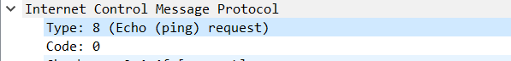



# What is the size of actual data exchanged and how many header are added with on different layers. Write the header name and size.

Size of Actual Data: 32 Bytes

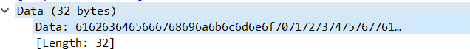

Three Headers are added on different layers:

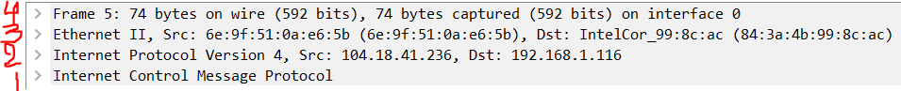

* 1. Application Layer (ICMP Header, Size: 8 Bytes)
  2. Network Layer (IPv4 Header, Size: 20 Bytes)
  3. Data Link Layer (Ethernet 2, Size: 14 Bytes)

Frame = ICMP (8 bytes) + IPv4 (20 bytes) + Ethernet (14 Bytes) + Actual Data (32 Bytes) = 74 Bytes

# 3.

* + 1. **Get the values from wireshark and fill the following IPv4 IP Header Table:**

|  |  |  |  |  |  |  |  |  |  |  |  |  |  |  |  |  |  |  |  |  |  |  |  |  |  |  |  |  |  |  |  |  |  |  |
| --- | --- | --- | --- | --- | --- | --- | --- | --- | --- | --- | --- | --- | --- | --- | --- | --- | --- | --- | --- | --- | --- | --- | --- | --- | --- | --- | --- | --- | --- | --- | --- | --- | --- | --- |
| 1 | | | | | | | | 2 | | | | | | | | 3 | | | | | | | | | | | 4 | | | | | | | |
| 0 | 1 | 2 | 3 | 4 | 5 | 6 | 7 | 8 | 9 | 10 | 11 | 12 | 13 | 14 | 15 | 16 | 17 | 18 | | 19 | 20 | 21 | | 22 | | 2  3 | 24 | 25 | 26 | 27 | 28 | 29 | 30 | 3  1 |
| Ver: 4 | | | | IHL: 20  (5) | | | | DSCP: CS0 | | | | | | ECN:  Not- ECT | | Total Length: 60 | | | | | | | | | | | | | | | | | | |
| Identification: 48923 | | | | | | | | | | | | | | | | Flags: | | | | | | | | | Offset: 0 | | | | | | | | | |
| 0 | | | 0 | | | | 0 | |
| TTL: 128 | | | | | | | | | Protocol: ICMP(1) | | | | | | | Header CheckSum: 0x278b [Validation disabled] | | | | | | | | | | | | | | | | | | |
| Source IP: 192.168.1.116 | | | | | | | | | | | | | | | | | | | | | | | | | | | | | | | | | | |
| Destination IP: 104.18.41.236 | | | | | | | | | | | | | | | | | | | | | | | | | | | | | | | | | | |
| Options: | | | | | | | | | | | | | | | | | | | | | | | | | | | | | | | | | | |

# What can be the minimum and maximum Header length?

Minimum IP Header Length: 20 Bytes Maximum IP Header Length: 60 Bytes

# What can be minimum and maximum size of IP Packet?

Minimum IP Packet Size: 20 Bytes

Maximum IP Packet Size: 216 = 65535 Bytes ( IP Header + IP Payload)